Operating Systems 2

Report Assignment - 2

EE17BTECH11041

The comparison of the three mutual exclusion algorithim is given below i the form of graphs. The first one is of the Average waiting time by each of the processes. Second is of the worst case waiting time of one process which shows whether a process is starving.

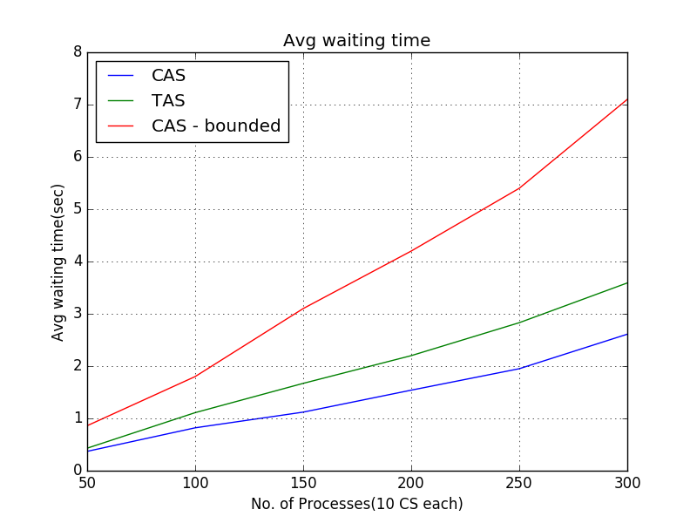

The average waiting time for bounded cas is higher when compared to the other mutual exclusion algorithms.

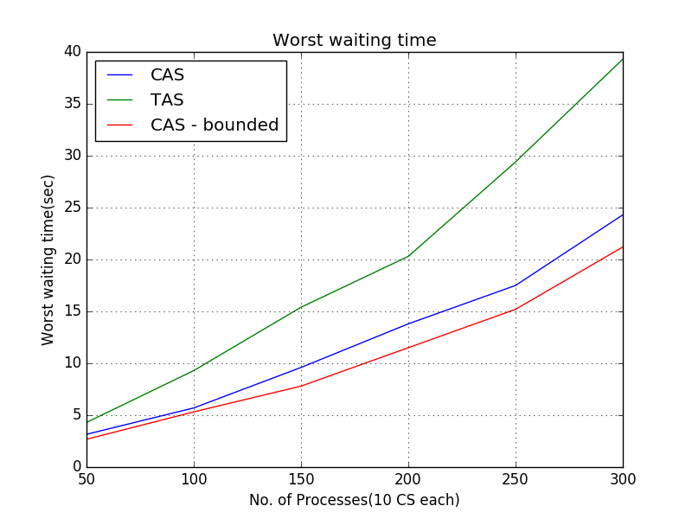As expexted worst waiting time is least for bounded-cas as we ensured bounded waiting.

Anomolies and Problems faced– The waiting time values were fluctuating highly every time the program is run due to many other processes. So I had to run many times to get satisfactory identical values.